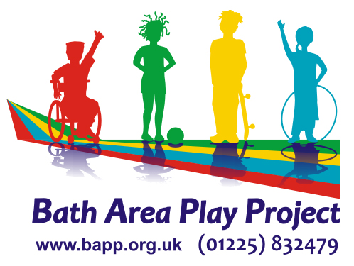

Job Description for B&NES Children & Young People’s
Network Co-ordinator
We are currently undertaking a Structural Review and as part of this, the role will become a project as part of a wider Community Engagement Manager role.
This will be a full time role for 12 months and open to job share.

We are currently recruiting for the CYP Network Co-ordinator position and looking for an exceptional individual, passionate about improving outcomes for children and young people and BAPP’s child-centred, inclusive values and keen to support the wider community. Training and support will be given for the right individual to become a part of the Management team.

Job Title: B&NES Children & Young People’s Network Co-ordinator/Community Engagement Manager
Responsible to: BAPP Director & Trustees & Funders
Main duties: To support voluntary and community sector groups working with children and young people in B&NES through dissemination of information; networking opportunities; partnership projects; and providing a representative role for the sector at key meetings to ensure clear and effective communication

Hours and Salary: NJC Scale Pt 19 - 23 £25,481 - £27,741 pro-rata
Up to 35 hours week, flexible
Job Description
Children & Young People’s Network
- To enable the VCS working with children & young people to have a voice at a strategic level through support of representatives of the VCS
- To participate in planning and delivery by providing information which is understandable and accessible and relevant to their needs.
- To facilitate meetings to enable the LA/CCG to consult with / explain about new developments or changes in procedure
- To organise and run a minimum of 4 Network meetings a year, usually one per quarter. This includes organising guest speakers, presentations and
- discussions related to topics or consultations.
- To provide a forum for representatives to gather diverse views of voluntary and community sector groups working with children and young people to take forward to meetings and feedback information
- Maintenance and provision of an up-to-date mailing list (GDPR compliant) of VCS organisations working with children & young people in B&NES and production of regular e-bulletins & distribution (12 times/year)
- Promote and encourage membership, increasing by 10% each year
- To maintain the number of actively engaged member groups through innovative and responsive initiatives
- Build and develop connections with agencies and businesses that will be of benefit to the Network and BAPP
- To expand our consultation, increase our volunteer capacity, and develop ongoing relationships with local partners
- Provide telephone/email advice and support to representatives of VCS and ensure reporting is shared, usually through E-bulletins
- To complete quarterly monitoring reports and all work related to Outcome Targets for the Contract including an annual evaluation
- To promote and support joint working opportunities and collaboration between the voluntary and community sector and the statutory sector and other not-for-profit organisations (e.g. schools, colleges, Higher Education Institutions) and keep each other informed of work progress and plans
- Lead on the development of Knowledge Exchange between organisations, notably HE
- To contribute to B&NES Strategic Children’s Plans involving CYP Network members.
- To contribute in the delivery of participation strategies for children, young people, their parents and carers
- To facilitate a forum where VCS groups can contribute views on specific issues which will then be taken back to the relevant meeting
- To support BAPP with the organisation and delivery of events and promotion including use of social media and website
- To act as a VCS representative on strategic meetings including LSCB/BCSSP and Children’s Workforce Training
Community Outreach
- Developing volunteering: recruiting, inducting and performance monitoring volunteers to support BAPP services and any wider programmes;
- Managing data and reporting on engagement and outreach activities to inform development;
- Providing information to promote awareness of BAPP’s work;
- Conducting community outreach and consultation at regular outreach events.

Community Engagement
- Identifying, building, and managing relationships internally and with partner agencies, VCS organisations, businesses and community
- Leading on Impact Measurement for BAPP; including parental evaluation of services and the child’s voice;
- Serving as organisational point of contact for new relationships, partnerships and events; and coordinating initial communications.

Marketing & Communications
- Managing BAPP’s social media platforms, ensuring consistent and competent messaging, and acting as the primary point of contact for community members on digital platforms;
- Developing flyers and promotional materials targeted to key user groups and the community;
- Preparing and editing external organisational correspondence, presentations, reports and memos with support from leadership team;
- Serving as the main point of contact for media inquiries and coordinating BAPP responses and media engagement.

Person Specification
- Excellent communication, networking, and facilitation skills
- Educated to degree level
- Experience of working within or with the children’s services sector
- Knowledge and experience of working in or with the voluntary sector and an understanding of the B&NES area
- Experience in creating electronic documents including promotional material
- Confident in the use of social media platforms, and online participation tools e.g. Padlet, Mentimeter
- Experience of community engagement and confident to develop an organisational impact measurement system
- Good understanding of the changing agenda related to children’s services including strategic implications and delivery issues
- Excellent IT skills including Word, Excel, PowerPoint, Email platforms e.g. MailChimp, and Design packages e.g. Canva

The role is based at the BAPP office in the Odd Down Community Centre where the post holder will be a keyholder. The hours can be worked flexibly Monday to Friday, ideally including a Monday. Some home working is possible.

Any travel to meetings, for the purposes of the role, mileage can be claimed.
BAPP offer NEST Pension scheme, Cycle to Work scheme, Early Years childcare (term time) as well as access to Training and CPD relevant to the post and how it will develop.

The post is funded through a mixture of funding sources and is subject to continuation of receiving these through achievement of targets and outcomes. 25 hours comes from St John’s Foundation under a commissioned arrangement through B&NES and up to 10 hours/week for 12 months to start from a Trust.

